

Software Documentation Tool for the MotorPH Payroll System 

Prepared and Presented by:

***Guirre, Lawrence***

***Gan, Charles Ferdiemar L.***

***Burce, Neina Jeizrei M.***

*Bachelor of Science in Information Technology*

*2nd Year 2nd Term 2023-2024*

# 

# Introduction

1.1 Purpose

This document guides the user on how to use the new payroll system for MotorPH.

The payroll system's main objective is to streamline and automate payroll processing, ensuring accurate and timely payment of employees while maintaining compliance with relevant laws and regulations.

1.2 Intended Audience

All MotorPH employees will be using the software, The Salary Calculation and Payroll Administrator function is given to the Human Resources Department.

1.3 Intended Use

This payroll system includes Employee Information Management, Time and Attendance Tracking, Salary Calculation, Employee Self-Service Portal, and Payroll Administrator Roles.

1.4 Contents

This guide includes the following contents:

1. **Getting Started**
2. **Payroll System Guide**
   1. Secure Login Procedures
   2. Salary and Deduction Calculation
   3. Leave Application
3. **Technical Information**

# Getting Started

* 1. Computer Requirements
     1. Hardware and System Requirements

The hardware requires a minimum of the following configurations:

* RAM: At least 1GB
* Disk Space: 124 MB for JRE, 2 MB for Java Update, and 2.5 GB for Software
* Processor: Minimum Pentium 2 266 MHz processor
  + 1. Software Requirements

The software needs the following application installed:

* Operating System:
  + - Windows 11, 64-bit, natively installed
    - Windows 10, all 64-bit editions, natively installed
    - Windows Server 2022, Standard and Essentials
    - Windows Server 2019, Standard and Essentials
    - Windows Server 2016, Standard and Essentials
    - Windows Server 2012 R2, Standard and Essentials
    - Windows Server 2012, Standard and Essentials
* Other Application: The latest version of Java.
  1. Access Guide

The software can be accessed by the user by opening the application installed on the computer.

## Payroll System Guide

* 1. Secure Login Procedures - on the MotorPH Login page user will input their login credential by inputting their username and password

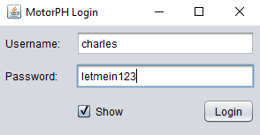

* 1. Salary and Deductions Calculations - the employee will enter their employee ID, and they can see their payroll information.

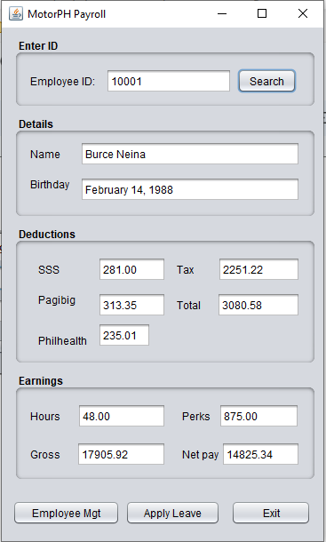

* 1. Leave Applications - the employee will click on the apply leave button then a popup window will appear. The employee's available leave will be seen, in the said window, and can apply their leave request but inputting the date and the leave type and then clicking on the Apply button.

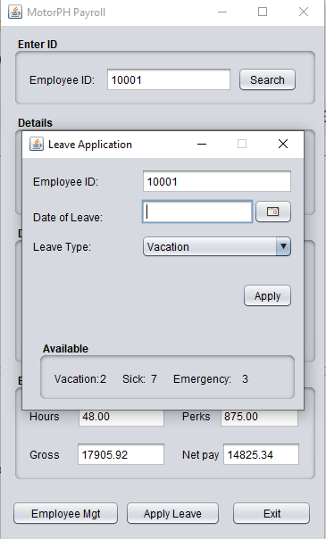

## Technical Information

* 1. Use Case Diagram
  2. **Use Case Narrative**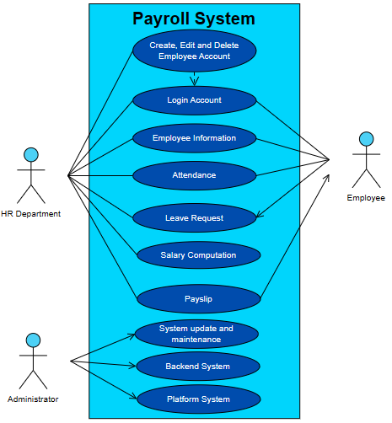
     1. **Identification: Payroll-HR 1.0 - HR Department**

| **Use Case ID** | Payroll-HR 1.0 |
| --- | --- |
| **Use Case Name** | HR Department |

* + 1. ***Use Case Definition***

| **Actor** | **HR Department:** Manage employee information, attendance management, and leave management |
| --- | --- |
| **Description** | HR Department roles |
| **Preconditions** | 1. The user identity has been authenticated. 2. The user's computer has sufficient free memory available to launch the task. |
| **Postconditions** | 1. The report should be for intended users.. 2. The Leave management report has been updated. |
| **Expected Outcome** | 1. Users can create, edit, and delete the employee user profile. 2. Users can track and generate attendance reports. 3. Users can approve or disapprove employees' leave. 4. Users can generate payroll reports. |
| **Exceptions** | Forget password - coordinate with IT department. |
| **Includes** | Payslip - for generating a report. |

* + 1. ***Normal Case of Events***

| **Step** | **Actor Action** | **System Response** |
| --- | --- | --- |
| *1* | *Login* | *Authenticate login credentials* |
| *2* | *Create account button* | *Create employee account* |
| *3* | *Employee data entry* | *Input employees information* |
| *4* | *Approve and Deny button* | *Approve or deny a leave request* |
| *5* | *Calculate Button* | *Calculate employee salary* |
| *6* | *Generate Button* | *Generate payslip* |

* + 1. ***Alternative Course of Events***

| **Step** | **Actor Action** | **System Response** |
| --- | --- | --- |
| *1* | *Edit account button* | *Edit employee data.* |
| *2* | *Archive account button* | *Put employee records into archives.* |

* + 1. **Identification: Payroll IT 2.0 - IT Department (Administrator)**

| **Use Case ID** | *Payroll-IT 2.0* |
| --- | --- |
| **Use Case Name** | *IT Department* |

* + 1. **Use Case Definition**

| **Actor** | **System Administrator (IT Department):** Read-only access to abstracted database entities and operations |
| --- | --- |
| **Description** | *The system admin or IT department role* |
| **Preconditions** | 1. The user identity has been authenticated. 2. The user's computer has sufficient free memory available to launch the task. |
| **Postconditions** | 1. Able to troubleshoot errors. 2. System update. |
| **Expected Outcome** | *Backup of database and code*  *Code maintenance of the payroll system*  *Server maintenance for OS and middleware updates and patching* |
| **Exceptions** | 1. *Malware- must be able to detect and terminate the malware, and restore the system.* 2. *Slow computer - computer upgrade.* |
| **Includes** | *Update and maintenance of the system* |

* + 1. **Normal Case of Events**

| **Step** | **Actor Action** | **System Response** |
| --- | --- | --- |
| *1* | *Login* | *Authenticate login credentials* |
| *2* | *System update* | *Update the payroll system* |

* + 1. **Alternative Course of Events**

| **Step** | **Actor Action** | **System Response** |
| --- | --- | --- |
| *1* | *Backup and restore* | *Backup database or restore from backup.* |

* + 1. ***Identification: Payroll-Employee 4.0 - HR Department***

| **Use Case ID** | Payroll-Employee 4.0 |
| --- | --- |
| **Use Case Name** | Employee |

* + 1. **Use Case Definition**

| **Actor** | **Employees:** Manage employee information, attendance management, and leave management |
| --- | --- |
| **Description** | Employees access |
| **Preconditions** | The user identity has been authenticated.  The user's computer has sufficient free memory available to launch the task. |
| **Postconditions** | 1. The report should be for intended users.. 2. The Leave management report has been updated. |
| **Expected Outcome** | 1. Users can create, edit, and delete the employee user profile. 2. Users can track and generate attendance reports. 3. Users can approve or disapprove employees' leave. 4. Users can generate payroll reports. |
| **Exceptions** | Forget password - coordinate with IT department. |
| **Includes** | Payslip - for generating a report. |

* + 1. **Normal Case of Events**

| **Step** | **Actor Action** | **System Response** |
| --- | --- | --- |
| 1 | Login button | Authenticate login credentials |
| 2 | View button | View employee detail |
| 3 | Payslip Button | View payslip |
| 4 | Leave button | Apply for leave |

* + 1. **Alternative Course of Events**

| **Step** | **Actor Action** | **System Response** |
| --- | --- | --- |
| 1 | *Feedback* | *Contact the HR department for errors.* |
| 2 | *View Button* | *View attendance.* |

* 1. Class Diagram

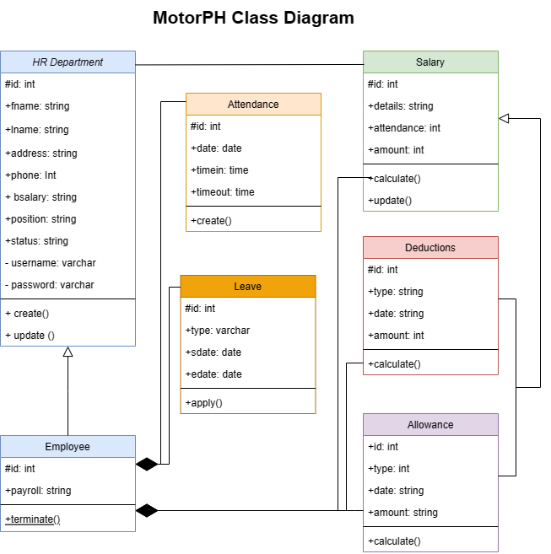

The Payroll System Management System is a modeled diagram that explains its classes and relationships. The diagram depicts the names and attributes of the classes, as well as their links and, their methods*.*

* 1. Test Case
     1. Internal

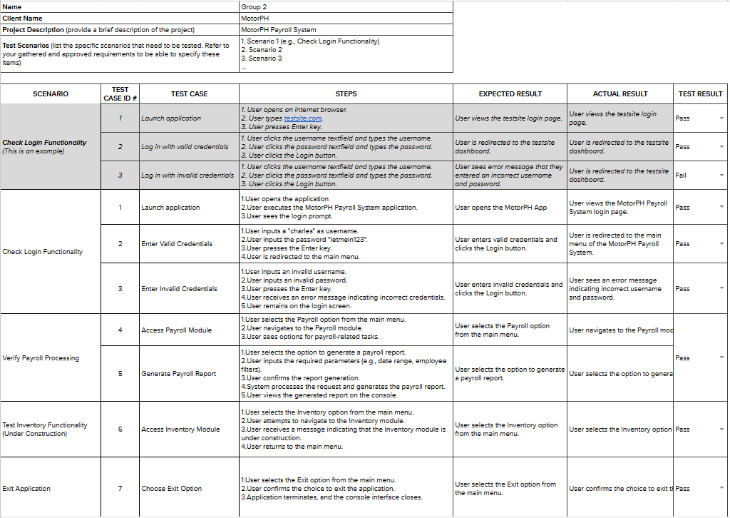

* + 1. External

[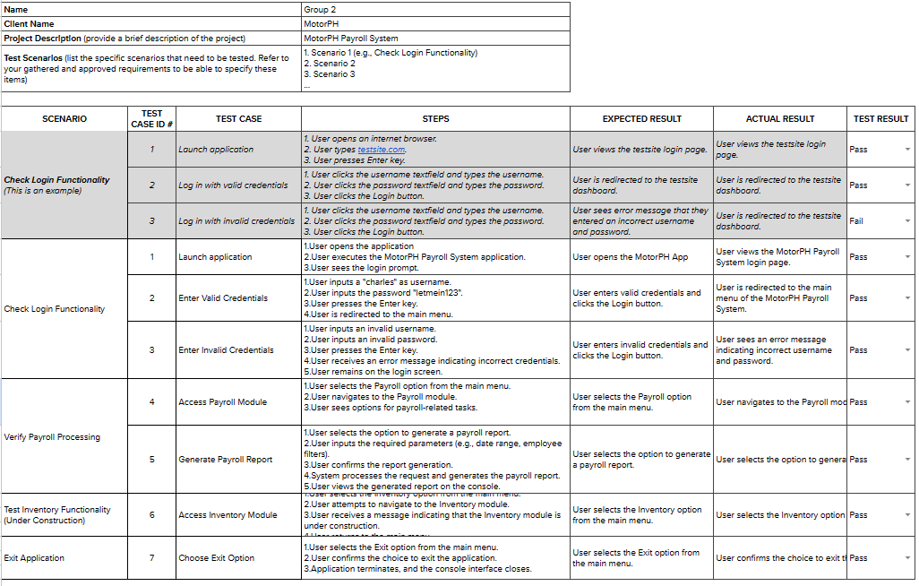](https://docs.google.com/spreadsheets/d/1xH5mxCP1VUIeCy99v1YoI9egR3Wh9-nBNl_NPgVKNec/edit?usp=sharing)